D. Introduction to Programming with RAPTOR
By Lt Col Tom Schorsch
The RAPTOR Programming Language
RAPTOR is a visual programming language based on flowcharts. Flowcharts were developed as a design aid for developing programs; however, with RAPTOR they are a programming language in their own right as the flowcharts you develop can be executed by the RAPTOR development environment.

We use RAPTOR in CS110 for several reasons. First, the RAPTOR language has minimal syntax (grammar) when compared with other programming languages. This makes Raptor programs easy to write as there are fewer language elements that you have to learn to be productive. Second the RAPTOR language is visual; RAPTOR programs are diagrams (directed graphs). One of the hardest aspects of programming to understand and get right is the flow of control of the statements in your program. The visual nature of the flow of control in RAPTOR programs makes them easier to understand and program. Third, we developed the programming language and development environment. We sought to make the development environment easy to use and the error messages that RAPTOR displays to you easy to understand. We are constantly trying to improve RAPTOR, so if you have suggestions please tell us. Fourth, our purpose is not to teach you how to program in particular language. We want to teach you how to design and execute algorithms to solve problems, and to implement algorithms using computer-based problem solving tools. These objectives do not require a heavy-weight commercial programming language such as C++ or Java.

What will you be missing by using RAPTOR instead of some other more conventional programming language? First, you will miss using a complex development environment that has been designed to be useful to professional software developers but is extremely difficult to use in an educational environment by novice programmers. Second, you will miss programming in a large complex programming language with complex syntax and semantics. Third, you will not see cryptic error messages describing the multitude of syntax errors you might commit while programming in the complex programming language using the complex programming environment.
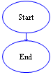
RAPTOR Program Structure
A RAPTOR program is a directed graph. When executing a program, you begin at the Start symbol at the top and follow the arrows to execute the program. Raptor programs end with the End symbol. The smallest RAPTOR program (which does nothing) is depicted at the right. By placing additional RAPTOR statements between the Start and End symbols you create more meaningful RAPTOR programs.

RAPTOR Variables
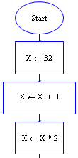
Variables are memory locations that hold a value. At any given time a variable can only hold a single value of a particular type of data, however, as the program executes, the data value stored in the variable can change. They are called variables because the data stored by them can vary as the program executes.

As an example, the RAPTOR statement X←32 assigns the data value 32 to the variable X. If that statement is followed by the statement X←X+1 the value of 32 is retrieved from X, the value 1 is added to it, and the result (33) is stored back in variable X replacing the value that was previously stored there. Thus, in the program at the right, the variable X initially had no value, then it is assigned the value 32, then it is assigned the value 33, and finally it is assigned the value 66. If you are reading this on-line (and have RAPTOR installed) you can execute the program by double-clicking here: Variable value changing over time Example.rap. You can step through the program and see the value of variable X change by clicking on the 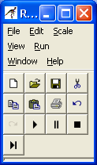 button.

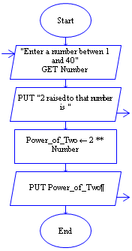
A variable is normally used to hold a value that is not known before the program starts running. This value could be read in from the user, or it could be computed from other values, and so the exact value that is stored in the variable may vary every time the program is run (another reason why it is called a variable).

Variables are one of the most important programming concepts as all code involves the processing of data that is stored in variables. It is variables, and their changing data values, that enable the same programs to act differently every time you run them and to solve different versions of the same problem. The program at the left gets a value from the user, the variable Number could have a different value each time the program is executed. Variable value different each time the program is run example.rap

An instructor will often ask a student to tell them the value of a variable. What they are asking for is the value that was last assigned to that variable or was read into that variable at a particular time during the program’s execution. The first assignment of a value to a variable is called initializing a variable. Variables do not automatically have values. If you try to use a variable’s value before it has been given one, expect a run-time error like the following.
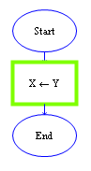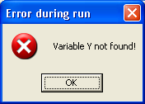

All variables should be given meaningful names by the programmer. The names that you use for variables should be easily understood and relate to the purpose the variable serves in your program. Remember, a variable name must start with a letter and can contain letters, numbers, and underscores (but no spaces or other special characters).

One way of understanding the purpose of variables is to think of them as a means to communicate information between one part of a program and another. By using the same variable name in different parts of your program you are using the value that is stored at that location in different parts of your program. Think of the variable as a place holder or storage area for values between their use in computations. Most of what a program does is to place values into variables and retrieve values from variables. When you get information from the user of a program, that information must be stored in a variable in order for you to use it later. When you perform a mathematical computation via an assignment statement, the resulting value is also stored in a variable for later use.

Many programs are based on getting data, processing the data, and displaying the results of your processing. All of this cannot be done without variables. For example, first you get data from the user and store that data in variables. Second, you perform some sort of computation using those variables (and the data that was entered and stored in them) and then store the results in still more variables. Finally, you display the results of your computations to the user by displaying the computed values that were stored in variables.

Variable |  | A variable is a value holder. The value of a variable can change during the execution of the program. Physically, variables are memory locations that hold a value. Using a variable identifier (its name) in an instruction enables data to be retrieved from, or stored to that memory location. All variables start with a letter and may contain additional letters, numbers, and underscores.

Unlike most programming languages, RAPTOR variables are not declared in a separate section of the program. Instead, RAPTOR variables are defined upon their first use. All RAPTOR variables are of type “Number” or “String”, meaning they could be a whole number like 12, 567, -342, etc., a floating point number like -12.4, 3.14159, 0.000369, etc., or a string value like “Hello how are you?”, “James Bond”, “Female”, etc.

As variables are not declared in advance, it can be easy to forget which variables you are using and to mistype the name of a variable. Either of these problems can lead to your program not working as you would like it to. For example, the variables Average and Avg are two different variables as their names are different. Based on their names, both variables probably store the average of something. However, the RAPTOR development environment cannot read your mind and determine if Average and Avg should be the same variable so it treats them as different variables. It is incumbent upon you, the programmer, to consistently use the same name for a variable in all of its uses in your program.

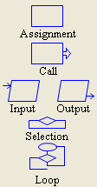
RAPTOR Statements
RAPTOR has 6 basic statements: Input, Output, Assignment, Call, Selection, and Loop. Each of these statements is indicated by a different symbol in RAPTOR as shown at the right.

The Selection and Loop statements are also called control structure statements. They are control statements because they control how the program executes. They are structured statements because they can enclose other statements.
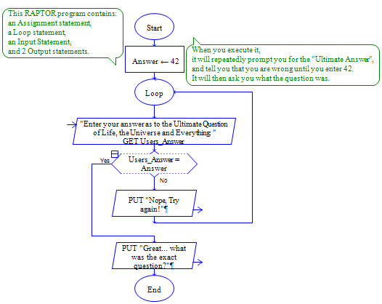

The RAPTOR program on the left contains examples of some of the 6 basic statements. The comment explains what the program does. Notice how the loop statement controls the execution flow and encloses other statements. Those of you that have read Douglas Adam’s book, The Hitchhiker's Guide to the Galaxy will understand the reference.

If you are reading this on-line you can execute the program by clicking on: The Ultimate Question of Life, the Universe and Everything.rap,
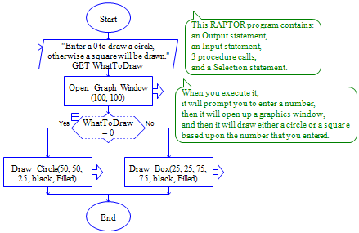

The RAPTOR program to the right contains examples of the remaining basic statements.

The comment explains what the program does. Notice how the selection control statement encloses other statements and that only one of the statements will be executed. To try it yourself, click here:
Draw_Example.rap.

Statement  or  Instruction |  | A programming language instruction to the computer. An executable statement that causes a specific action to occur when the program is run.

The Assignment, Call, Input, and Output statements are described below. A separate reading describes the Selection and Loop control structure statements.
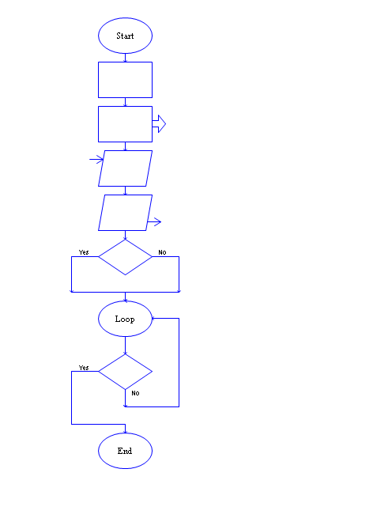
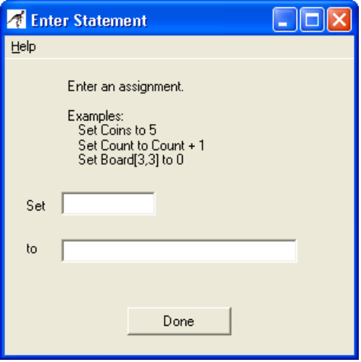
Assignment Statement

Programming often involves using formulas to compute some value. The assignment statement is used to perform a computation and then store the results in a variable. The value stored in the variable can then be retrieved and used in a later statement in the program.

The dialog box at the right is used to enter both the name of the variable being assigned and the computation that will be evaluated and whose result will be assigned to the variable.

Syntax for an assignment statement
<Variable> ← <Expression> or Set <Variable> to <Expression>

An example assignment statement is:

Cost ← (Tax_Rate * Non_Food_Total) + Food_Total
Assignment Symbol
Expression to be evaluated and assigned during run time

Variable being assigned

Expression |  | Any sequence of literals, variables, operators, etc. that, during run-time, can be evaluated to produce a single value. That value is referred to as the result of the expression.

The semantics for an assignment statement are:
- Evaluate the expression on the right hand side of the assignment operator.
- Take the value that was calculated and place it in the memory location associated with the variable, replacing whatever data value had been stored there previously.

Assignment |  | An assignment statement is used to modify or replace the data stored at the memory location associated with a variable.

Built in Operators and Functions
An operator or function directs the computer to perform some computation on data. Operators are placed between the data being operated on (i.e. X/3, Y+7, etc.) whereas functions use parentheses to indicate the data they are operating on (i.e. sqrt(4.7), sin(2.9) ). When executed, operators and functions perform their computation and return their result. RAPTOR has the following built-in operators and functions.
basic math: +, -, *, /, ^, **, rem, mod, sqrt, log, abs, ceiling, floor
trigonometry: sin, cos, tan, cot, arcsin, arcos, arctan, arccot
relational: =, !=, /=, <, >, >=, <=
logical: and, or, not
miscellaneous: random, Length_of

The basic math operators and functions include the familiar (+, -, *, /) as well as some that are unfamiliar.
** and ^ are exponentiation, ex 2**4 is 16, 3^2 is 9
rem (remainder) and mod (modulus) return the remainder (what is left over) when the right operand divides the left operand, ex 10 rem 3 is 1, 10 mod 3 is 1 also
sqrt returns the square root, ex sqrt(4) is 2
log returns the natural logarithm, ex log(e) is 1
abs returns the absolute value, ex abs(-9) is 9
ceiling rounds up to a whole number, ex ceiling(3.14159) is 4
floor rounds down to a whole number, ex floor(10/3) is 3
+ also works as a concatenation operation to join two strings or a string and a number,
ex “The average is ” + (Total / Number)
Length_Of returns the number of characters in a string variable (also the number of elements in an array which you will learn about later), ex Name ← “Stuff” followed by Length_Of(Name) is 5

You should be familiar with the trigonometric functions (sin, cos, tan, cot, arcsin, arcos, arctan, arccot). They work on angles whose units are radians. (i.e. you must convert from degrees to radians before using these functions.). The arctan and arccot are the two parameter versions of these functions. (i.e. arctan(X/Y) is written in RAPTOR as arctan(X,Y)).

In RAPTOR, the relational operators and logical operators can only be used in decisions as part of Selection and Loop statements, which are discussed more fully in the next reading. Relational operators are =, != (not equal to), /= (not equal to), <, >, >=, and <=. The relational operators return a “Boolean” value true or false (yes or no). For example, the operation X<Y would return true if the value stored in variable X is less than the value stored in variable Y. Otherwise false is returned. The results of a relational operation can be used by logical operators.

The logical operators are defined by the following tables. The operands used by the logical operators should be “Boolean” values (meaning the values returned by relational operators or logical operators).

Expression |  | Result
True and True |  | True
True and False |  | False
False and True |  | False
False and False |  | False
Expression |  | Result
True or True |  | True
True or False |  | True
False or True |  | True
False or False |  | False
Expression | Result
not (True) | False
not (False) | True

The random function returns a number between 0 and 1, ex X←random could be 0, 0.23, 0.46578, etc. If you need a random number in a different range then you can combine the random function with other operations. For example, random*100 will evaluate to a number between 0 and 100. ceiling(random*100) will evaluate to a whole number between 1 and 100.

Built in Constants
Constants are pre-defined variables whose values cannot be changed. RAPTOR has the following built-in constants.
constants: pi, e, true, false, yes, no

pi is defined to be 3.14159274101257.
e is defined to be 2.71828174591064.
True and Yes are defined to be 1.
False and No are defined to be 0.

The constants True, False, Yes, and No are used by the RAPTOR execution system to determine the results of a decision.

Procedure Call statements

You have heard that a pilot follows take-off and landing procedures, a car mechanic follows a procedure to change your oil or replace your transmission, and you probably have a procedure for shining your shoes. I follow the change-oil procedure myself, but I get a car mechanic to do the replace transmission procedure for me when that becomes necessary. Typically, a procedure has something that it is acting upon, like the specific transmission and car. Similarly, a called procedure often must be supplied data, and it often returns data. In this class you will only be calling procedures, not creating procedures.

A procedure is a named collection of programming statements that accomplish a task. Calling a procedure suspends execution of your program, executes the steps associated with the called procedure, and then returns back and starts executing your program again. You do not have to see the instructions or even know what they are in order to use a procedure; you just have to know what the procedure will do to use it properly.

To use an existing procedure, you must call it by invoking its name and providing it with data that it needs. You may call a procedure many times sending it different data each time. Similarly, a car mechanic may know the procedure for replacing a transmission (or it could be written down in a book) and could execute that procedure on many different cars and rebuilt transmissions. Thus you can talk and reason about the procedure separately from the specific item (be it a specific transmission or a specific piece of data) a procedure is acting upon.

The Draw Example (several pages ago) contained 3 examples of procedure calls which are repeated below. The first opens up a graphics window that is 100 pixels wide by 100 pixels high. The second draws a circle centered at pixel 50, 50 with a radius of 25 pixels. The last draws a box that has a lower left corner at pixel 25, 25 and an upper right corner at pixel 75, 75. Both the circle and square are black in color and both are filled. By changing any of the data being passed into the procedure, you change what the procedure does.

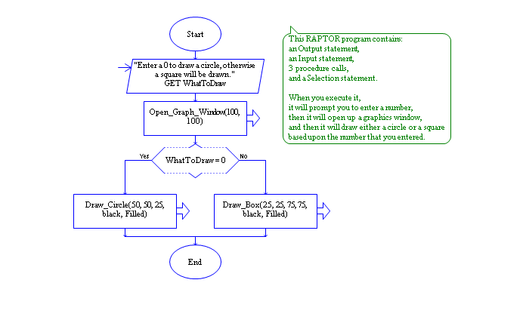

Built in Procedure

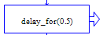
The delay_for procedure pauses the execution of the program for the number of seconds specified. delay_for is not a function or a operation and can’t be used in an assignment statement. Instead, it should be used in a call. Ex, delay_for(0.5) delays operation for half a second.

Input statements

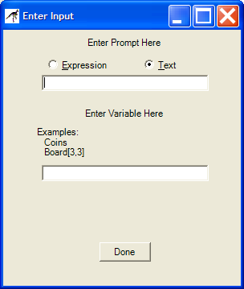
Every programming language has statements that enable the program to get information from the user of the program via the keyboard and that can display information on the computer terminal. Without such statements the user could not type instructions to the computer or give the computer requested information. Nor could the program display messages to the user, provide results to the user, or request information from the user.

An input statement is a special type of procedure that gets information from the user of the program so that the program can act upon it.

In RAPTOR, an input statement displays a prompt to the user (prompting them to input a value) and then gets a single value and stores it in a given variable. In RAPTOR, a dialog box asks you for the prompt to use and the variable in which to store the entered data.

The prompt should be as explicit as possible. If a value in particular units is desired (such as a height in feet or meters) you should mention the units in the prompt.

As you can see by the “Enter Input” dialog box at the right there are two types of input prompts, Text prompts and Expression prompts. An Expression prompt enables you to mix text and variables together like the following prompt: “Enter a number between ” + low + “ and ” + high + “: ”.

Output statements

In RAPTOR, an output statement is a special type of procedure that displays a value to the output screen. A dialog box asks you to identify whether you are writing out an expression or text (using a radio button) and whether a new line will be output (using a checkbox). The dialog boxes depict different examples depending on whether Number or Text output is chosen (see below).

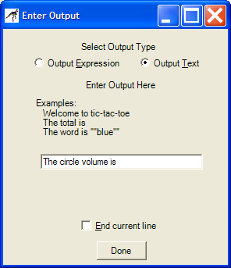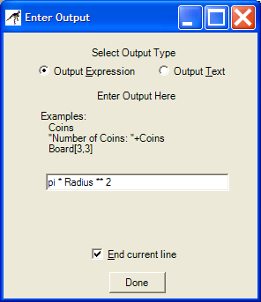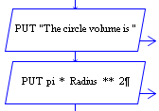

When outputting text, you can place additional spaces after the text as shown in the dialog box to the left above and in the RAPTOR program to the right above. This will cause the Number output to be separated from the text by a space. When outputting an Expression, you can write out a mathematical expression as well as a variable as shown in the dialog box in the middle above.

Your instructor (or your assignment) will also often say “Display the results in a user-friendly manner”. What your instructor means is that you should not just write out the results numbers, but you should also write out some explanatory text explaining what the number is. In other words, you should tell the user what the data is ("The circle volume is "), and then display the data as was done in the RAPTOR code above and to the right.

Selection and Loop statements
As mentioned previously, the selection and loop statements are described in a separate reading.
Comments in RAPTOR
RAPTOR, like many other programming languages, allows you to add comments to your program. The sole purpose of a comment is to explain some aspect of a program. Comments should inform or add information for the reader, especially in places where the program code is complex and hard to understand. Comments are not executed and mean nothing to the computer but can be very informative to the human reader.

Comment |  | Explanatory text that is written for the human reader of the program code. Comments are not instructions to the computer.

What we have learned…

We understand the basic structure and parts of a RAPTOR program.

We know what the arithmetic, logical, and relational operators are and what they can do.

We know purposes of and how to use the 6 basic RAPTOR statements.

We know how to display information in a user-friendly fashion.

We understand what an expression is and can evaluate an expression to determine its value.

We can assign a value to a variable using an assignment statement

Reading Self-Check

1. Label the following RAPTOR identifiers as (L) legal or (I) Illegal. If illegal then explain why.
_L___ 1) This_Is_A_Test
_L___ 2) U_2
__I__ 3) Money$
_L___ 4) Thisisanawfullylongidentifiername
_I___ 5) Mickey-Mouse
_I___ 6) 365_Days
_L___ 7) Begin
__L__ 8) End_Of_Data
__L__ 9) Variable
__L__ 10) Procedure
__I__ 11) Is This Identifier Legal
__I__ 12 Why_Isn’t_This_One_Legal

2. Why are comments important?

3. True or False. In RAPTOR, a variable does not have a value (in its memory location) until a program instruction gives it a value. False → It is initialized with a value.

4. Identify both the result of the following expressions or indicate if the expression is in error

Result
__________ 1) 46 / 2
__________ 2) 46 / 3
__________ 3) 46 rem 3
__________ 4) 46 ** 2
__________ 5) 12 < 13
__________ 6) 35 > 90
__________ 7) 120 /= 60*2
__________ 8) 46 < 49.5
__________ 9) True and False
__________ 10) (False and False) or True
__________ 11) (45.6 < 32.4) or (14 < 28)
__________ 12) 8 < 10 < 20
__________ 13) True and 7
__________ 14) 4**4 < 121.456
__________ 15) 77 + -1128
__________ 16) (3 * 3)**2 < 80 or (True and (67.5 < 121.5))

5. Identify the following as (A) Arithmetic, (L) Logical, or (R) relational operators.

____ 1) !=
____ 2) **
____ 3) /
____ 4) not

